### ****Project Description****

SparkBoard is a web-based application created by Team RHL Innovations to help student teams and creative groups manage, prioritize, and track project ideas. Its goal is to provide an intuitive platform for posting new ideas, voting on promising ones, commenting for collaboration, and tracking progress from concept to implementation.

### ****Requirements Summary****

SparkBoard is designed to work across both desktop and mobile devices, with responsive design ensuring usability on smaller screens such as smartphones and tablets. Key functional requirements include the ability to post new ideas, upvote/downvote ideas, add comments, update idea status, and view a dynamic feed of ideas. The application emphasizes a clean and intuitive interface to promote ease of use and engagement. Usability criteria include fast task completion times, minimal errors, and a clear visual hierarchy for idea status.

|  |  |
| --- | --- |
| **Requirement Type** | **Specification** |
| Compatibility | Android 8.0 and higher (iOS version in development) |
| Required Storage | 150 MB and higher |
| Memory Ram | 2 GB minimum |
| Internet | Required for cloud sync and collaboration |
| Bluetooth | Not required |

### ****Prototype Description****

**Overview of the Prototype**  
The SparkBoard prototype was developed using Figma, a collaborative prototyping tool that allows rapid iteration and easy sharing. The prototype includes the full user flow for posting ideas, interacting with ideas, and managing idea status.

**Mock-up/Prototype Details**

SparkBoard is designed to work across both desktop and mobile devices, with responsive design ensuring usability on smaller screens such as smartphones and tablets. Key functional requirements include the ability to post new ideas, upvote/downvote ideas, add comments, update idea status, and view a dynamic feed of ideas. The application emphasizes a clean and intuitive interface to promote ease of use and engagement. Usability criteria include fast task completion times, minimal errors, and a clear visual hierarchy for idea status.

### ****Prototype Description****

**Overview of the Prototype**  
The SparkBoard prototype was developed using a collaborative prototyping tool that allows rapid iteration and easy sharing. The prototype includes the full user flow for posting ideas, interacting with ideas, and managing idea status.

**Splash Screen Login Page Home page Comment Section**

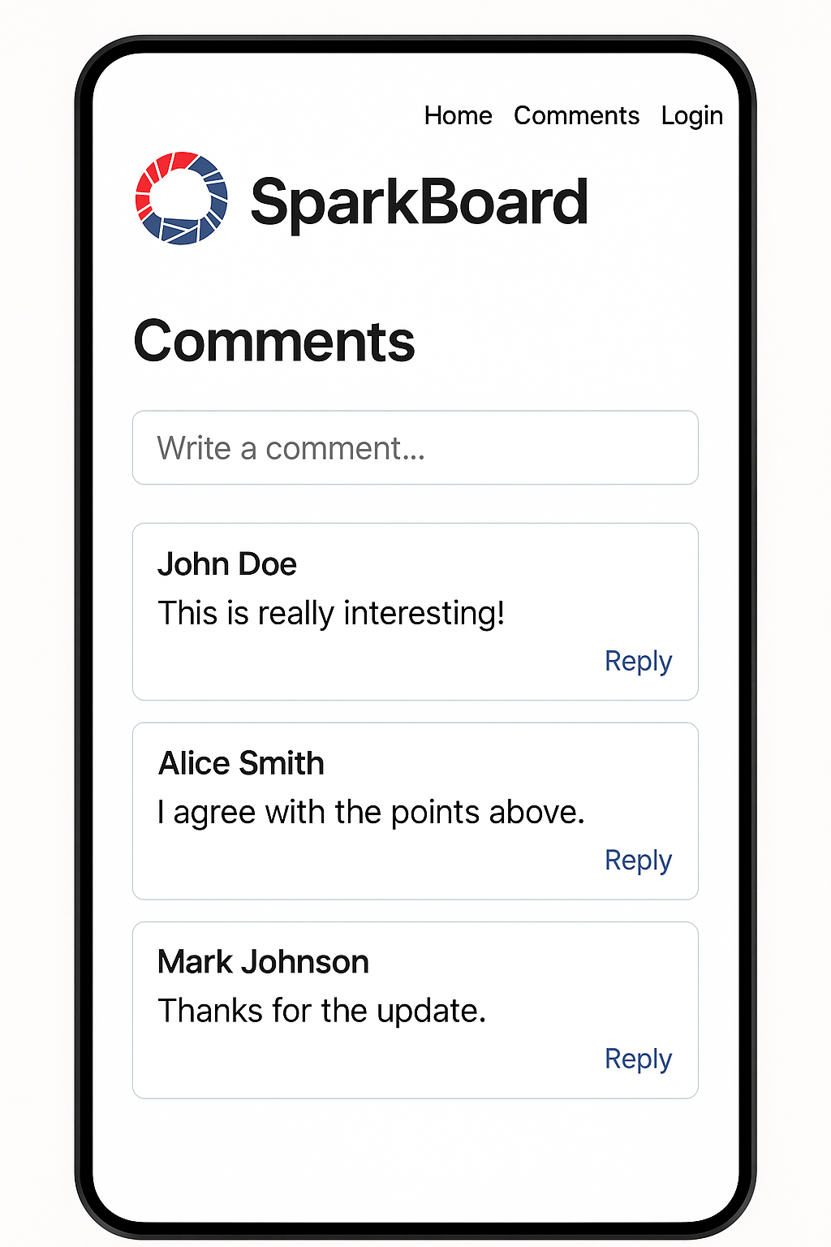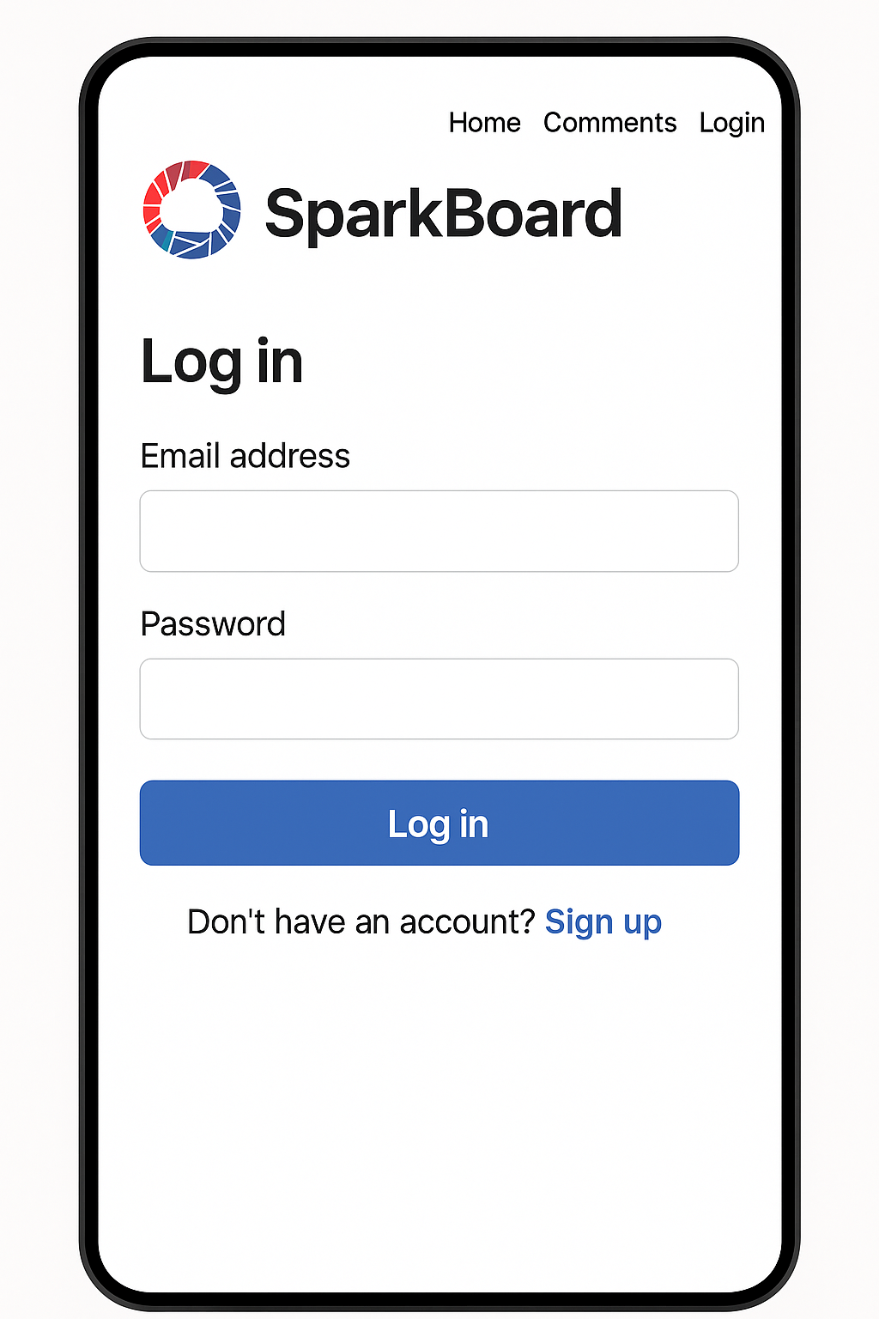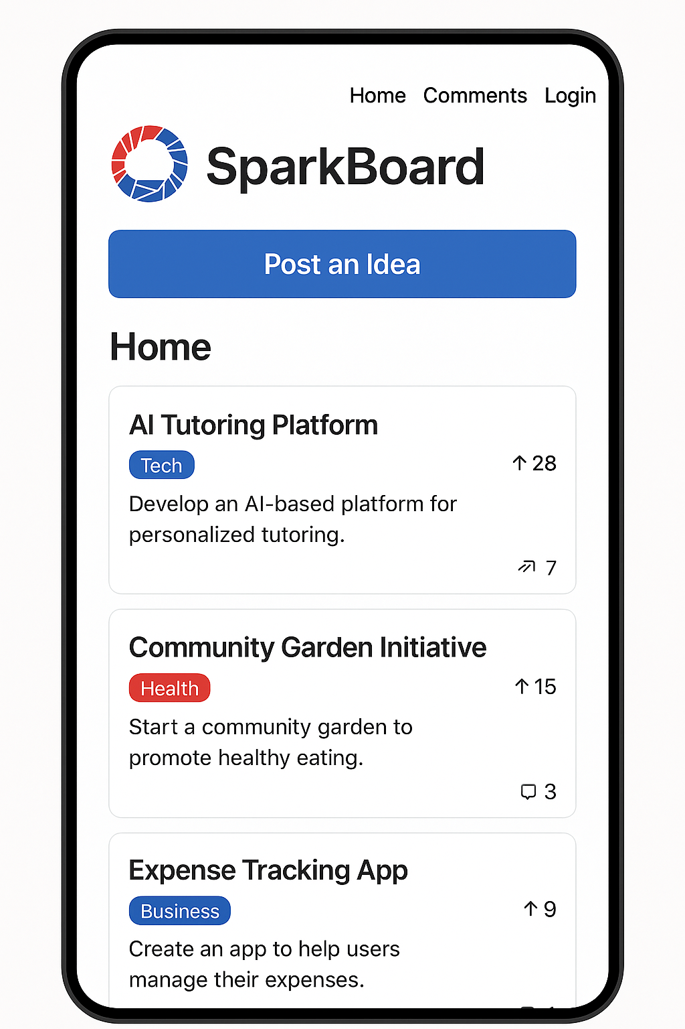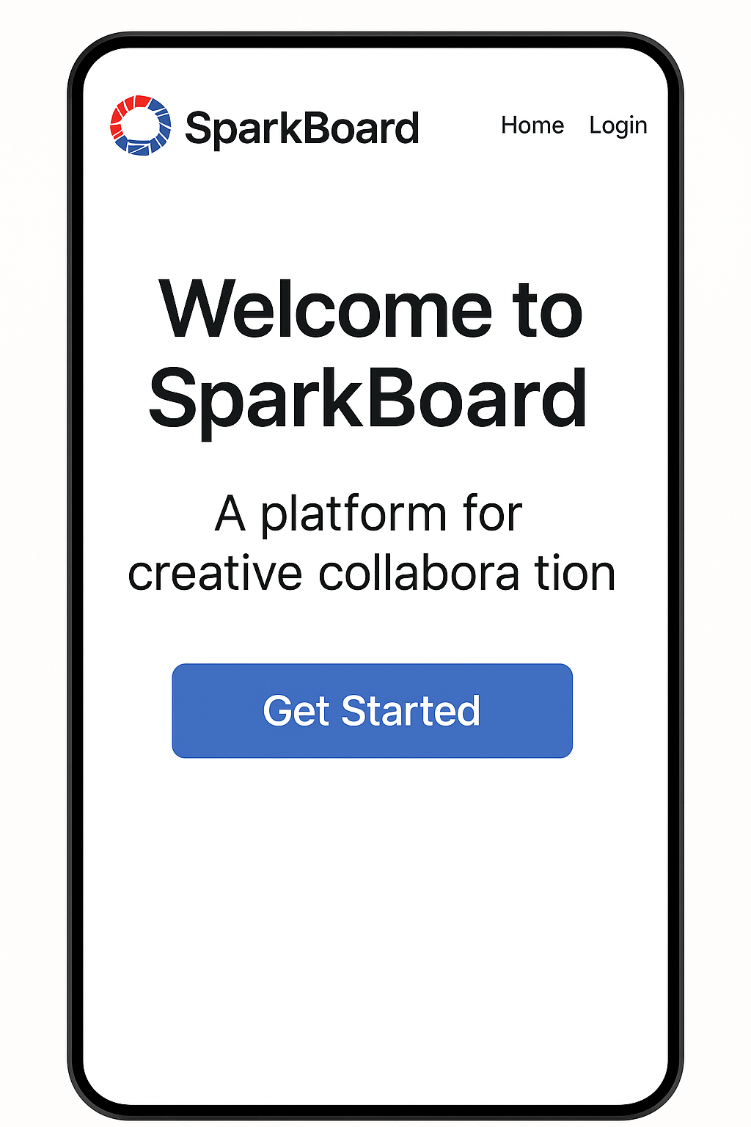

**Rationale**  
Figma was chosen for its interactivity, ease of distribution, and collaborative editing capabilities. This prototype emphasizes fast, clear interaction for key tasks: posting ideas, voting, commenting, and tracking progress — which aligns with SparkBoard’s goals. The simplicity of the design helps avoid confusion and minimizes the learning curve. One challenge faced was simulating backend interactions (vote counters, live updates), which were not fully implemented at this stage.

**Changes to Requirements**  
During the design process, usability criteria were revised to focus more on visual clarity and ease of interaction on mobile devices. The need for color-coded status labels emerged from feedback, and extra navigation layers were simplified. Originally planned notification features were deferred for future development to prioritize core functions first.

### ****Initial Evaluation Plan****

**Usability Specifications**  
The prototype will be evaluated for:

* **Effectiveness:** Users should be able to successfully complete tasks (post idea, vote, comment, update status).
* **Efficiency:** Users should post an idea in under 30 seconds; vote and comment within 2 clicks.
* **Learnability:** Users should be able to understand core features after 1 minute of exploration.
* **Satisfaction:** 80% of users should report positive experiences in post-test surveys.

**Evaluation Population**  
A sample of 10–15 students (project team members and organization leaders) will be recruited for usability testing.

**Prototype Tasks**

* Post a new idea
* Vote on an idea
* Comment on an idea
* Update status of an idea

**Evaluation Techniques**

1. **Benchmark Tasks:** Users will perform set tasks while being timed and observed.
2. **Observation & Error Tracking:** Researchers will record task completion, errors, and difficulties.
3. **Participant Survey & Feedback:** After testing, users will complete a survey (Likert scale + open-ended questions) regarding ease of use, clarity, and satisfaction.

**Survey Questionnaire Sample Items**

* It was easy to post an idea.
* I understood how to vote on an idea.
* The idea status was clear and understandable.
* The app felt simple and intuitive to use.

Survey responses will help determine whether SparkBoard is ready for further refinement and full development.